**Review a database schema**

So far, you’ve learned about the differences between various types of database schemas, the factors that influence the choice of database schemas, and how to design a database schema for a data warehouse using best practices.

In this reading, you’ll review a database schema created for a fictional scenario and explore the reasoning behind its design. In your role as a BI professional, you’ll need to understand why a database was built in a certain way.

**Database schema**

Francisco’s Electronics is launching an e-commerce store for its new home office product line. If it’s a success, company decision-makers plan to bring the rest of their products online as well. The company brought on Mia, a senior BI engineer, to help design its data warehouse. The database needed to store order data for analytics and reporting, and the sales manager needed to generate reports quickly to track the sales so that the success of the site can be determined.

Below is a diagram of the schema of the **sales_warehouse** database Mia designed. It contains different symbols and connectors that represent two important pieces of information: the major tables within the system and the relationships among these tables.

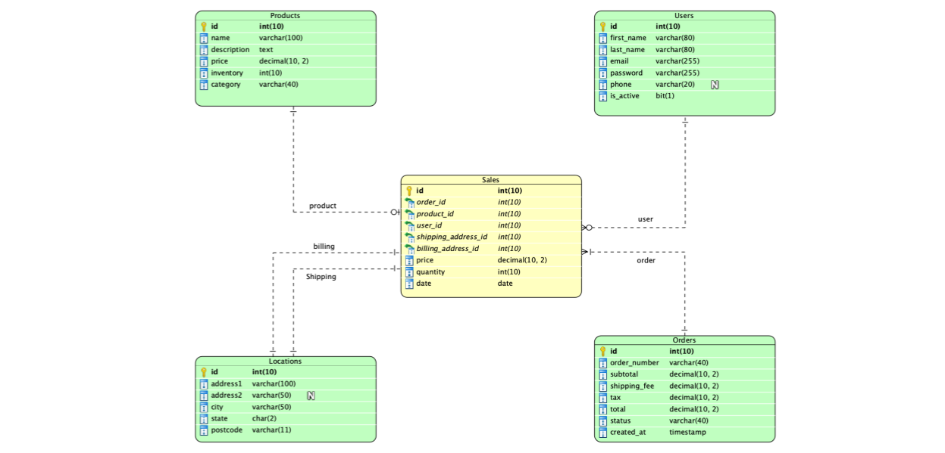

The **sales_warehouse** database schema contains five tables: Sales, Products, Users, Locations, and Orders, which are connected via keys. The tables contain five to eight columns (or attributes) that range in data type. The data types include varchar or char (or character), integer, decimal, date, text (or string), timestamp, bit, and other types depending on the database system chosen.

**Review the database schema**

To understand a database schema, it’s helpful to understand the purpose of using certain data types and the relationships between fields. The answers to the following questions justify why Mia designed Francisco’s Electronics’ schema this way:

* What kind of database schema is this? Why was this type of database selected?

Mia designed the database with a **star schema** because Francisco’s Electronics is using this database for reporting and analytics. The benefits of star schema include simpler queries, simplified business reporting logic, query performance gains, and fast aggregations.

* What naming conventions are used for the tables and fields? Are there any benefits of using these naming conventions?

This schema uses a snake case naming convention. In snake case, underscores replace spaces and the first letter of each word is lowercase. Using a naming convention helps maintain consistency and improves database readability. Since snake case for tables and fields is an industry standard, Mia used it in the database.

* What is the purpose of using the decimal fields in data elements?

For fields related to money, there are potential errors when calculating prices, taxes, and fees. You might have values that are technically impossible, such as a value of  $0.001, when the smallest value for the United States dollar is one cent, or $0.01. To keep values consistent and avoid accumulated errors, Mia used a **decimal(10,2)** data type, which only keeps the last two digits after the decimal point.

**Note: Other numeric values, such as exchange rate and quantities, may need extra decimal places to minimize rounding differences in calculations. Also, other data types may be better suited for other fields. To track when an order is created (created_at), you can use a timestamp data type. For other fields with various text sizes, you can use varchar.**

* What is the purpose of each foreign and primary key in the database?

Mia designed the Sales table with a primary key ID and included foreign keys in the other tables to reference the primary keys. The foreign keys must be the same data type as their corresponding primary keys. As you’ve learned, primary keys uniquely identify precisely one record on a table, and foreign keys establish integrity references from that primary key to records in other tables.

| **Sales table key id & foreign keys** | **Associated table** |
| --- | --- |
| **order_id** | **Orders** table |
| **product_id** | **Products** table |
| **user_id** | **Users** table |
| **shipping_address_id** | **Locations** table |
| **billing_address_id** | **Locations** table |

**Key takeaways**

In this reading, you explored why a database schema was designed in a certain way. In the world of business intelligence, you’ll spend a lot of time modeling business operations with data, exploring data, and designing databases. You can apply your knowledge of this database schema’s design to build your own databases in the future. This will enable you to use and store data more efficiently in your career as a BI professional.